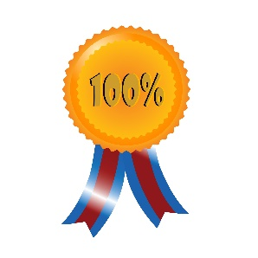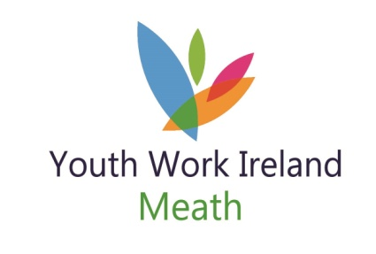

Volunteer
Recognition Celebrations

Get your thinking hats on.

Look around you …. go on …… right now …… look around you.

Who do you know that inspires you?

Who earns your respect and admiration?

Who is the first person opening up or the last person leaving the club?

Who holds the keys?

Who do you go to when you need advice or support?

Who makes the costumes, or washes the kit?

Who makes sure there are tea bags and coffee …… and those nice biscuits?

Who drives the bus?

Who’s first up the mountain, or into the freezing water?

Who knows when to listen?

Close your eyes……..who do you see?

Well then how about nominating them for

Youth Work Ireland Meath’s Volunteer Recognition Award

The awards will be hosted on Saturday 25th May 2019
Nomination forms will be available by email; on our website; by post
Closing date for Nominations will be 17th May 2019
For further details contact:
Lisa Moroney – Volunteer & Youth Club Support 046-9093402 or 087-0906062

Volunteer
Recognition Celebrations

Youth Club name:
Name/s of Volunteer you are nominating:

Why do they inspire you?

Why have they earned your respect and admiration?

Why do you go to them if you need advice or support?

What makes they special?

Youth Work Ireland Meath’s Volunteer Recognition Award

The awards will be hosted on Saturday 25th May 2019
Nomination forms will be available by email; on our website; by post
Closing date for Nominations will be 17th May 2019
For further details contact:
Lisa Moroney – Volunteer & Youth Club Support 046-9093402 or 087-0906062

